Upstream Impoundments Layer

# Meeting Notes

* Need something to get at network structure
* Contain distance, size, and contribution to temperature
* Some exponential decay function of the impact of impoundments on temperature at a site as they get further away

$$\sum{i*e^{-\frac{aw}{d}}}$$

Where:

$$i=impoundment area$$

$$w=Contributing drainage area to impoundment$$

$$d=distance from point of interest to impoundment$$

$$a=impoundment specific coefficient (to be calibrated in model)$$

* Alternate definite for w: $w= \frac{impountment D.A.}{site D.A.}$
* Mechanistic scaling? Add something for branchiness?

# Deliverables (to Dan)

* Dataframe of site, impoundment ID, w, d, i
* Cut off at 25 km upstream

# ArcGIS Notes

* The *Locate Features Along Routes* tool is used to compute the fraction along the flowline where the waterbody layer intersects.
* Inputs:
  + Input Features: Waterbodies Layer
  + Input Route Features: NHD Flowline
  + Route Identifier Field: COMID
  + Event Type: LINE
  + From-Measure Field: FMEAS
  + To-Measure Field: TMEAS

The result is a table with FMEAS and TMEAS columns linked to a FEATUREID column. The FMEAS is the percentage along the reach where the line first intersects (entering) the polygon and TMEAS is the percentage along the reach where the line intersects the polygon for the second time (leaving). The values are measured from the downstream end to the upstream end.

# Issues

* Some waterbodies span multiple stream segments and cover only parts of the flowlines due to inconsistencies between Flowlines and Waterbodies datasets. See Images:

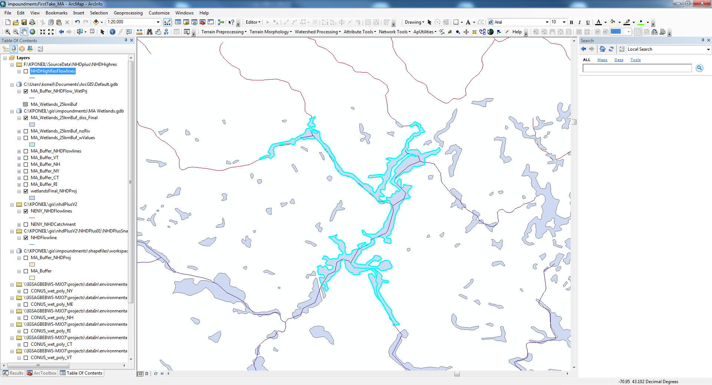 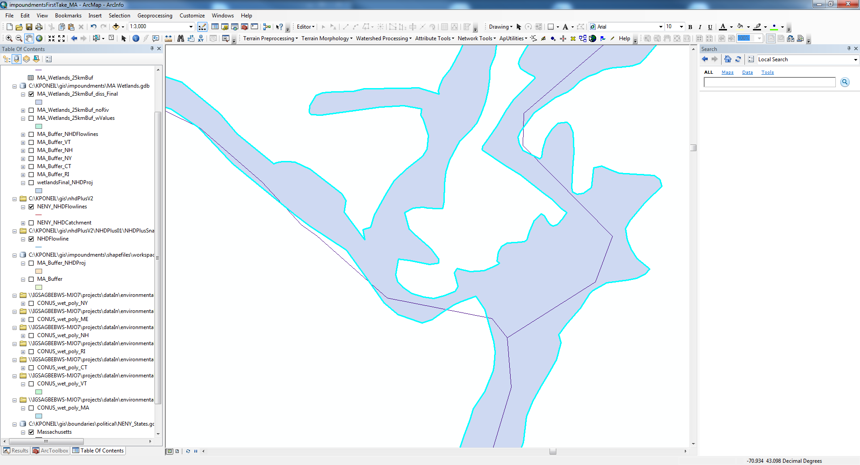

Working on this

Potential solution is to work upstream searching for the same waterbody. Need to incorporate a waterbody ID into the script.

* In R the duplicate Waterbodies are eliminated by selecting the minimum distance from the downstream point.

The waterbodies are analyzed by state datasets, which overlap.

**Impoundment IDs**

# Each waterbody gets a unique ID. These are assigned in the original state shapefiles. The numeric values are only unique to each shapefile, creating duplicates when the GIS output tables are joined in R. As each table gets read into R, the state abbreviation is added to the “Object_ID” field to prevent confusion between waterbodies with the same numeric ID. Eg. (Object_ID: “10” from Vermont becomes “VT10” when read into R). From here on these tables are grouped by catchment and waterbody area, which is precise enough to differentiate between the relatively small number of waterbodies within each catchment.

How to assign this? does it need to be associated with the state?

# There might be an issue with overlaps where some get assigned to different state than they fall in.

# R Notes

# Final Workflow

R script to create directory structure

ArcPy script to do GIS processing

R script to do final processing

1 waterbodies shapefile for processing.

All flowlines that overlap that area.

Select the flowlines by waterbodies shapefile extent